STRATEGY

 | Summary
2 | Competitive Landscape
 | 3rd Party Services
 | Notiˆcation Events
 | Go to Market
 | Terminology
 | Personas
 | Goals
 | Initiatives
 | Labels

DEFINE

Onboarding

Views

Homepage Feed - Logged In

Index View

Home Page Feed - Not Logged

In

Detailed View

Live Feed

Registration

User Types

Phone Number Veriˆcation

Uploading and Feedback

Media

Share a product video

Unassigned Stories

Editor

Views

Summarize the main page views of the product

Homepage Feed - Logged In

Initially, everything is displayed chronologically rather than algorithmically or based on votes.

Since the user base will be relatively small at ˆrst, we won’t have enough people voting to

meaningfully rank products (yet).

DEFAULT INITIATIVE SPRINT 2 0 Vadim Muravjov

Subtasks (2)

Index View

The Index View (ie, homepage) displays the list of posts chronologically, segmented by day (a la

linkydink).

When not signed in, a CTA must be presented to signup. When signed up, a CTA to post must

be present.

The “Hunters” (ie, contributors) must also be listed, highlighting the community of product

people curating the content.

DEFAULT INITIATIVE SPRINT 1 0 Designers DE

Subtasks (7) 43%
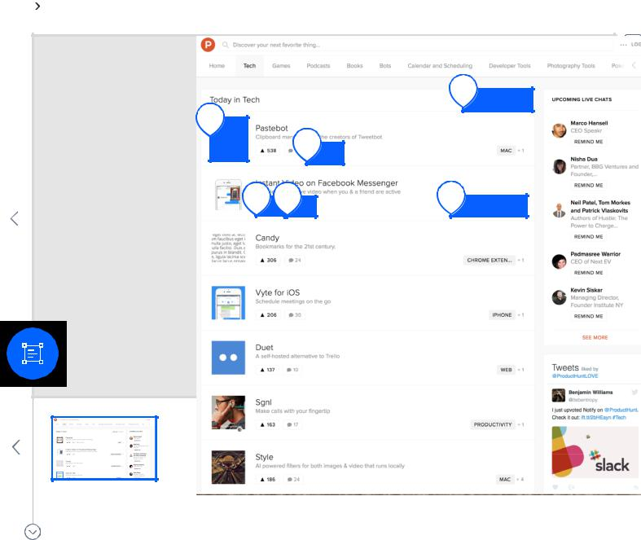

5

6

2

1 | 3 | 4

38%

1.png

1.PNG 6 Stories
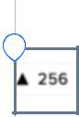

1 | See number of upvotes
 | SPRINT 1 | 0 | DE

